**Stats 101B Final Project Report - Spring 2018**

The Effects of Caffeine and Exercise on Memory Test Performance

**Group #16 Members/Authors:**

Gerard Agbangnin, Melissa Duffus, Moonseok Heo, Jaspreet Kang, Seungwoo Hong, Konner Macias, Breanna Ramos, Tyler Rodriguez, Hayley Todd

**Introduction**

As college students, we balance a plethora of activities on a daily basis: academics, work obligations, club commitments, research projects, social events, and so much more. Due to our busy lifestyles, we typically forget to complete certain necessary tasks such as submitting an assignment or contacting our loved ones. Our group was therefore eager to investigate factors that could potentially improve short term memory, and hopefully find a way to solve these aforementioned struggles as college students and for post-graduate life. After researching several experiments conducted by highly reputable sources, we discovered that coffee and exercise seem to be key factors that may demonstrate immediate effects on memory. We first decided to use coffee as a factor because researchers at the National Institute on Aging performed a study involving the use of caffeine on the results of 10 cognitive scores, concluding that there are “putative beneficial effects of caffeine intake...on domains of global cognition, verbal memory, and attention” (Beydoun). As for exercise, there was a study done on young male rats at the US Library of Medicine in which they studied the effects of “short term...term treadmill exercise on...memory consolidation”, discovering that the “test had significant (p=0.006 and p=0.001 respectively) effects on memory consolidation” (Saadati).

We decided to test this research question by analyzing the results of a controlled experiment in which we applied our treatments of coffee and exercise to the subjects, testing their memory performance using a memory test before and after treatment. Our population of interest hailed from the Islands, where 27 villages are dispersed throughout the three main islands. After visiting several villages and thoroughly examining the islanders’ attributes, we were intrigued by the inhabitants of Mahuti due to their relatively large population and diverse demographics. Mahuti is located in the southern islands and had a population of 2345 at the time of our experiment.

We expected the experiment to showcase an improvement in the memory test performance after one or both of our treatments of coffee and exercise had been applied. We also hypothesized that exercise would have an even greater effect than coffee due to the results of the aforementioned study on rats. By gathering a large randomized sample, and then also randomizing the application of our treatments to the subjects, we should be able to satisfy all the needed assumptions in order to properly form conclusions about the main and interaction effects of coffee and exercise on memory performance.

**Design of the Experiment**

To test whether coffee and exercise affect memory performance, we decided to use a 22 factorial design with one blocking factor. This design is highly advantageous because it allows us to study the joint effect of our two treatment factors, coffee and exercise, on our response variable, the difference between the time is takes to complete a memory test before and after our treatments. Ultimately, we decided to block by age since studies indicate that “memory is one of the cognitive functions that deteriorates most with age”, and more specifically that “the types of memory most affected by aging [include] the short-term memory maintenance” (Daselaar). Due to this arising information, our initial motivation had changed. We were no longer interested in solely focusing on college aged individuals. Instead, we expanded our age range to older adults as well, since we now know that different ages may produce different results. So we decided to incorporate four different age groups: 20-29, 30-39, 40-49, and 50-59. To summarize our experimental design thus far:

The design involves two treatments (22):

1. Coffee (250 mL)
2. Light Jog (5 mins)

With our response variable was the difference between memory test scores before and after our treatments.

The design will contain four treatment combinations:

1. Neither coffee, nor exercise (--)
2. Only coffee (+ -)
3. Only exercise (- +)
4. Both coffee and exercise (++)

The design will have one block with four levels:

1. 20-29
2. 30-39
3. 40-49
4. 50-59

To collect our sample, we utilized simple random sampling, a method in which every individual is equally likely to be selected. In order to do so, we visited each house within the village and asked all eligible residents within that house if they would like to participate in our study. More specifically, we only requested content from individuals within our 20-59 age range. If a resident granted consent for our study, we included him/her in our master population list. Once we visited and requested consent from the entire population, we used a random number generator to randomly select our participants from our master list. We selected a total of 64 participants in our study, which is a relatively large sample size considering we only technically needed 16 total runs to perform the experiment (2 factors * 2 levels per factor * 4 levels of our block). In order to confirm that 64 is an adequate sample size, our group also conducted a power anova test and discovered that the sample size needed was in fact 4 per group. Using these results from the power anova test, we took 4 participants from each age group and randomly assigned them to a treatment combination until we had a total of 16 participants per treatment combination.

After randomly assigning treatments to subjects, we conducted our experiment. We started by collecting baseline memory test scores from all 64 participants, and then administered each participant’s assigned treatment. To reiterate, there were four treatment combinations that subjects from each age group received, including only coffee, only exercise, both coffee and exercise, or neither coffee nor exercise. If a subject was assigned both treatments, he/she would perform the light jog first, then consume 250 ml of coffee shortly afterwards. Once the treatment was applied, we waited five minutes and had the participants perform the memory test again. After the scores were collected from each participant, we calculated the difference between their pre-treatment score and their post-treatment score, documenting our obtained results below.

**Results and Interpretation**

First, in order to make some initial observations on which factors may be significant in our model, we calculated all main and interaction effects, looking to see which seemed to be relatively large. Displayed below are our estimated effects, and we can see that the effect of exercise is definitely the largest, so will most likely have the most significance within the model. However, caffeine seems to have a much smaller effect, indicating it may not be as significant as we originally thought. In order to uncover more about the significance of our factors, we then ran our ANOVA test.

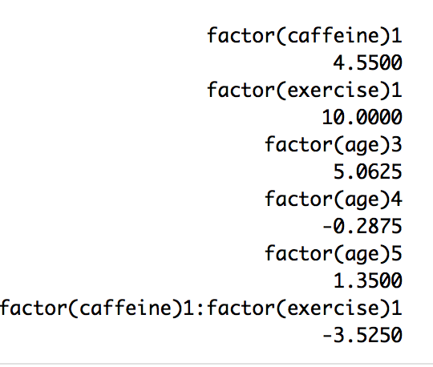

After performing an ANOVA test, of which we have displayed the output below, we noticed that the main effect of exercise on memory test performance is in fact significant, as it has a p-value of 0.0162, which we can see is clearly less than our significance level of $α=0.05$. However, the main effect of coffee and also the interaction effect of both coffee and exercise were not significant with p-values of 0.4051 and 0.5979 respectively, each of which were greater than 0.05.

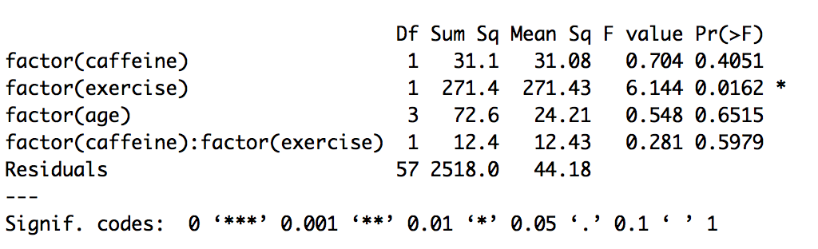

Contrary to our initial intuition, caffeine turns out to have no significant effect on the results of the memory game, whereas exercise does have a significant main effect. Although age is our blocking factor, we notice that the difference in memory test performance is not affected by age group.

After observing the results of our ANOVA test, we then wanted to check our model validity. To do so, we plotted our residuals vs fitted plot and also a Normal Q-Q plot. Once we had our plots, we noticed that we do in fact have constant variance over the fitted values, and our residuals tend to follow a normal distribution as displayed on the normal Q-Q plot with signs of very few to no outliers. Both of these plots suggest that the normality assumptions are satisfied, and therefore our model is valid.

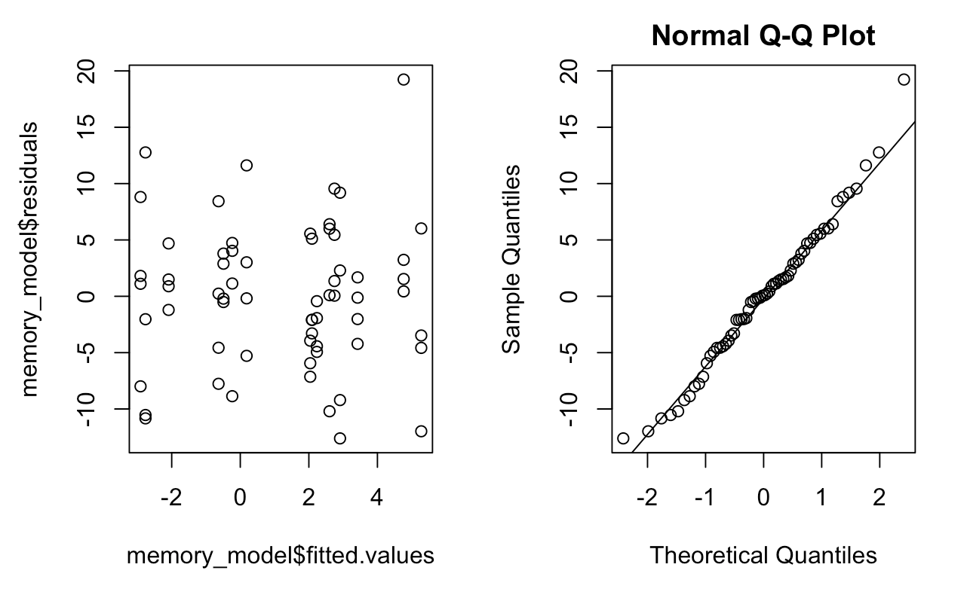

Now, since we knew our model was valid, and we had also discovered from our experimental trials that exercise is in fact a significant factor in affecting the difference between pre- and post-exercise memory test scores, we then decided to determine exactly what kind of effect it has: positive or negative. It is important to note for clarification that once again, these memory test results were based on the amount of time is took to complete the test, not a raw percentage scores. So, higher differences indicated more time taken to complete the test, whereas we were hoping for a negative difference, indicating an improvement in results. We ran a main effects plot of our factors, which can be seen below. From this, we discovered something that we were not expecting: exercise actually produced a negative effect on our participant’s short term memory results.

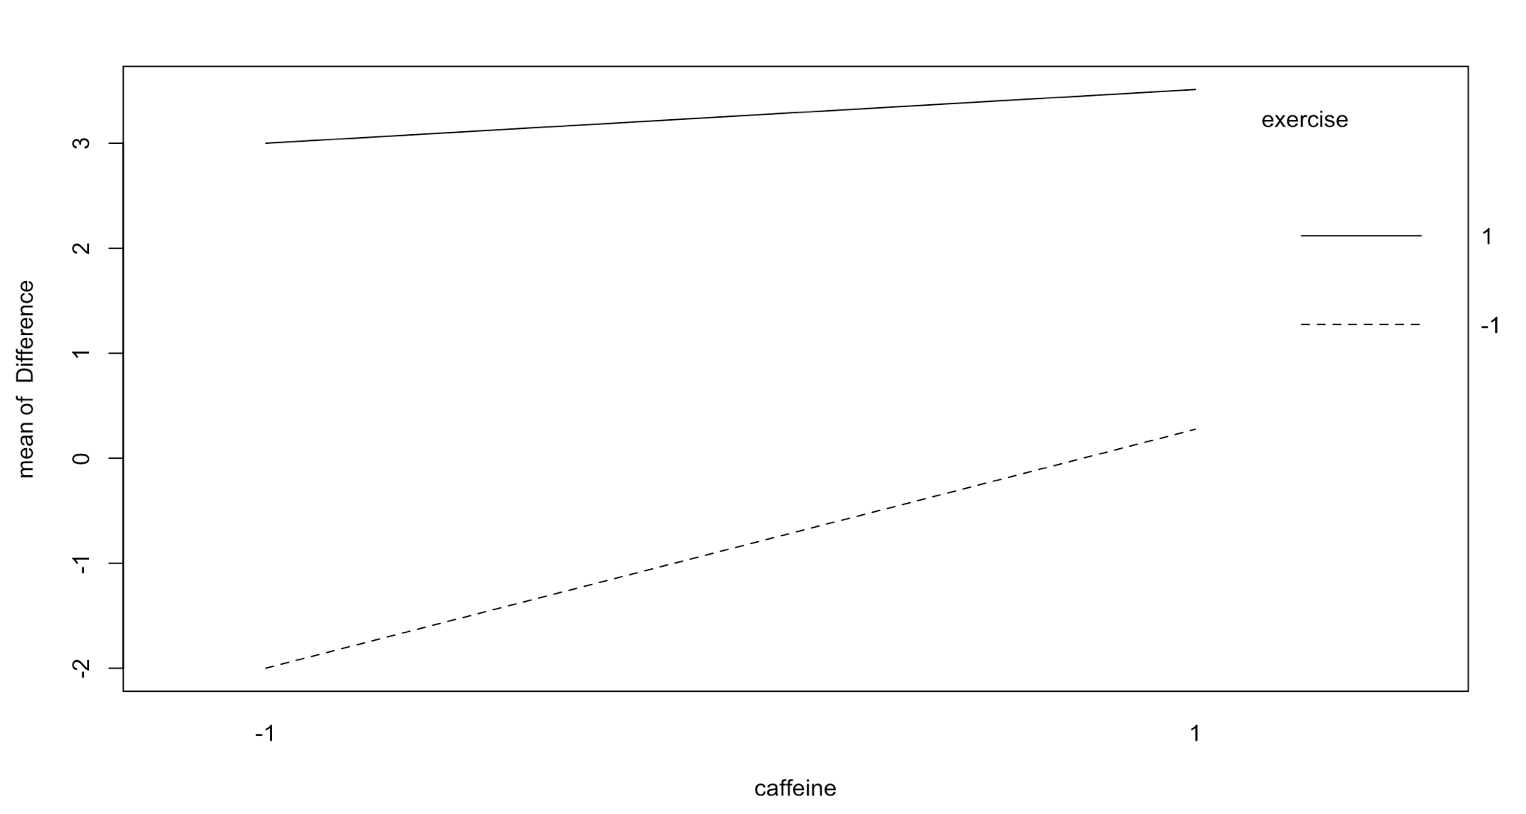

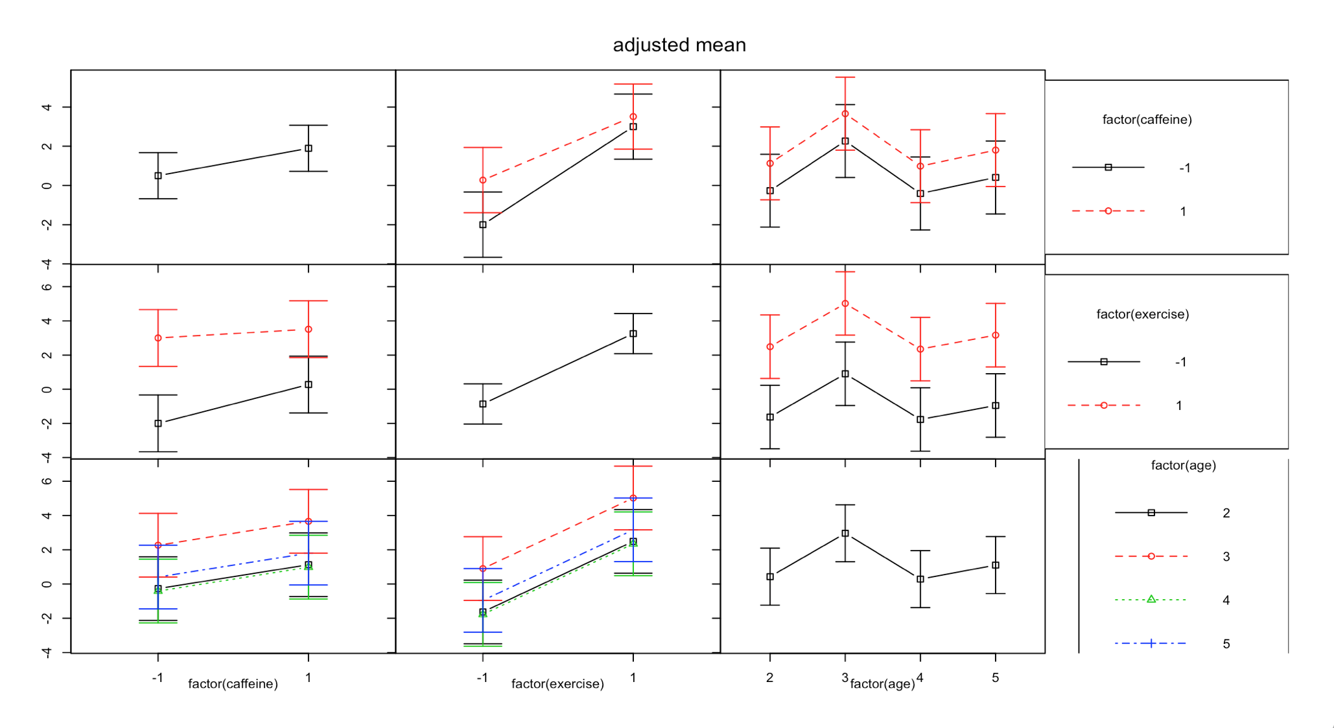

Just to further confirm our findings regarding the significance of our factors, we displayed a plot of all main and interaction effects. As for the main effects of caffeine, we see a horizontal line trend suggesting that the main effect is insignificant. Transitioning to the exercise portion of our plot, regardless of caffeine treatment or age, we see that the dotted line representing participants who were given exercise as their treatment is consistently above the solid line. Notice that the high level of exercise (1), results in a larger difference in average response time for completing the memory test.Therefore, we once again notice that exercise for our participants resulted in a negative effect on memory game performance. Lastly, we can also conclude that there is no interaction effect between the two, due to the fact that the lines on the interaction plots are fairly parallel.

**Discussion**

In our experiment designed study the effects of caffeine and exercise on memory performance, we observed that coffee had no significant effect on the timed memory test results. Similarly this conclusion was the case for the interaction effect between caffeine and exercise. Nevertheless, we noticed that exercise individually does have a significant effect, but it actually worsened the participant’s memories, rather than improving it as we had hoped. Thus, our initial hypotheses that the treatments of caffeine and exercise would improve memory performance were rejected.

Our conclusions for the effect of exercise on memory can be further corroborated by an experiment done by a different study, in which researchers had their subjects participate in 30 minutes of either high or low intensity exercise, and then testing memorization of vocabulary they had studied prior to the exercise. Similar to our results, their participants also showed that the short-term exercise “did not enhance the absolute number of recalled words” (Hötting).

As for further exploration, we have several ideas. First of all, in regards to our experiment and possible improvements, after our tests and further insight, we realized that blocking by age was not completely necessary since we were measuring the difference in before and after test results, rather than raw scores. Therefore, taking the difference in scores should not be affected by age group, which is confirmed by our ANOVA results. More exploration could be done in which we block by a different factor, possibly one that has been shown to affect the difference in scores across a range of levels.

Since exercise was our significant factor in this study, we also believe that looking into different types of exercise, such as aerobic or resistance training, might reveal new information about the treatment. For example, possibly participating in swimming, weight lifting, or yoga before the test could have improved performance better the light jog. We also think this would be a good avenue to explore since this theory, based on yoga, has been tested and shown that those “who practiced yoga module yielded higher concentration levels and exhibited better short term memory” (Kauts).

Additionally, in regards to caffeine, in order to find a significant effect we could also try blocking by time of day that the treatments are given. Outside credible experiments have been done that seem to show that “caffeine has a specific benefit for memory during students’ non-optimal time of day – early morning”, but not the afternoon, so this could also be an interesting variation of the topic to explore (Sherman). Finally, it would be interesting to analyze whether caffeine or exercise would have any long term benefits by applying the treatment over the course of 2 weeks or more before having participants take the memory test, a study that has also been tested at Johns’ Hopkins, actually producing positive effect results (Gatlin).

Works Cited

Beydoun, May A., et al. “Caffeine and Alcohol Intakes and Overall Nutrient Adequacy Are Associated

with Longitudinal Cognitive Performance among U.S. Adults | The Journal of Nutrition | Oxford

Academic.” *OUP Academic*, Oxford University Press, Journal of Nutrition, 17 Apr. 2014, academic.oup.com/jn/article/144/6/890/4615979.

Daselaar, Sander, and Roberto Cabeza. “Age-Related Decline in Working Memory and Episodic

Memory.” Edited by Kevin N. Ochsner and Stephen Kosslyn, *Oxford Handbooks*, Oxford

University Press, Dec. 2013,

[www.oxfordhandbooks.com/view/10.1093/oxfordhb/9780199988693.001.0001/oxfordhb-978019](http://www.oxfordhandbooks.com/view/10.1093/oxfordhb/9780199988693.001.0001/oxfordhb-978019)

9988693-e-001

Gatlin, Latarsha. “Caffeine Has Positive Effect on Memory, Johns Hopkins Researchers Say.” *The Hub*,

12 Jan. 2014, hub.jhu.edu/2014/01/12/caffeine-enhances-memory/.

Hötting, Kirsten, et al. “The Effects of Acute Physical Exercise on Memory, Peripheral BDNF, and

Cortisol in Young Adults.” *US National Library of Medicine National Institutes of Health*, PubMed Central, 29 June 2016, www.ncbi.nlm.nih.gov/pmc/articles/PMC4942640/.

Kauts, Amit, and Neelam Sharma. “Effect of Yoga on Concentration and Memory in Relation to Stress.”

*ResearchGate*, ResearchGate,

https://www.researchgate.net/publication/268437629_EFFECT_OF_YOGA_ON_CONCENTRATION_AND_MEMORY_IN_RELATION_TO_STRESS.

Saadati, Hakimeh, et al. “Effects of Exercise on Memory Consolidation and Retrieval of Passive

Avoidance Learning In Young Male Rats.” *US National Library of Medicine National Institutes*

*of Health*, PubMed Central, Sept. 2010, www.ncbi.nlm.nih.gov/pmc/articles/PMC3289178/.

Sherman, Stephanie M., et al. “Caffeine Enhances Memory Performance in Young Adults during Their

Non-Optimal Time of Day.” *US National Library of Medicine National Institutes of Health*, U.S.

National Library of Medicine, 14 Nov. 2016, www.ncbi.nlm.nih.gov/pmc/articles/PMC5107567/.